Calculating Hub index and ETI from Ecopath with Ecosim (EwE)
This documentation describes how to generate some files useful for considering the state and function of marine ecosystems, which can be useful in taking an ecosystem oriented approach to fisheries management. It assumes you are obtaining your “data” from Ecopath with Ecosim (EwE) and processing it with R quarto code EBFM_indicator_calculation.qmd

There are 2 stages to this process.
- Generating the base information – typically done via EwE (as described here), though it is possible to generate it from data if you have sufficiently long and comprehensive data time series (this is not described in this instance)
- Calculating the hub species and ecosystem indicators (using the R code in EBFM_indicator_calculation.qmd)
EwE – creating the necessary simulations
EwE is currently used as the easiest way of accessing information on consumption, biomass, catch and predation mortality through time.

Information needed from EwE
- Ecopath output:
  - Consumption matrix
  - Diet matrix
- Ecosim output (csv):
  - biomass_annual.csv
  - catch_annual.csv
  - consumption-biomass_annual.csv
  - catch-fleet-group_annual.csv
  - mortality_annual.csv
  - mort-fleet-group_annual.csv
  - landings_annual.csv
  - tl_annual.csv

The information is required for the scenario of interest (e.g. historical scenario) and an unfished state.

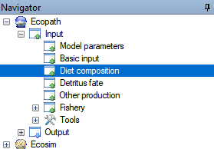
Obtaining the Ecopath consumption and diet matrices
Open your Ecopath model.
First to save the diet matrix, click Ecopath then Input and select Diet composition.

Then click the “Save to csv” icon on the extreme right-hand side of that page (it is a small white rectangle with an arrow pointing out of the rectangle).

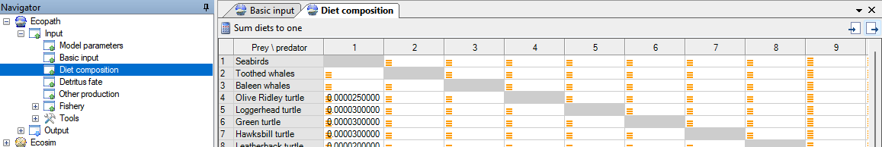

This will open a dialog box so you can decide where to save the file and what to call it.

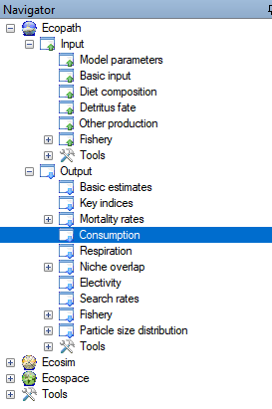
Now to save the consumption matrix, click Output then Consumption. Again click the “Save to csv” icon on the extreme right-hand side of that page to open the dialog box to save this matrix to a csv file.

Note you do not need to make any modifications to these files, the quarto code will make all necessary modifications.

Generating the Ecosim (historical) fishing scenario

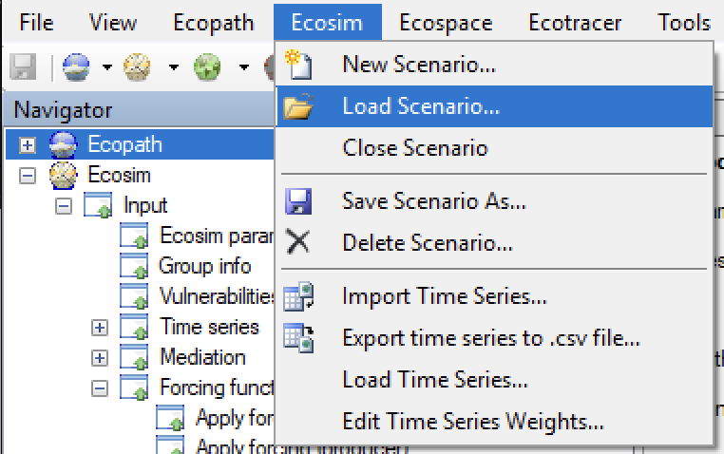
Generating the scenario of interest – in this case the historical fishing scenario – is done in the standard way for Ecosim:
- Open the calibrated Ecosim model by clicking Ecosim and loading the relevant scenario

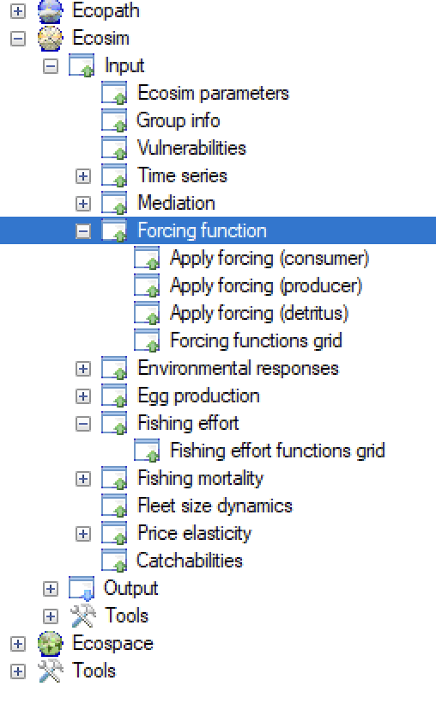
- Include any desired environmental forcing - typically done by entering a Forcing function for primary production applied via forcing the primary producer, often phytoplankton, groups

Temperature and other environmental forcing of mortality and forage rates is also now possible via the Environmental response option (please consult the EwE manual for information on that)

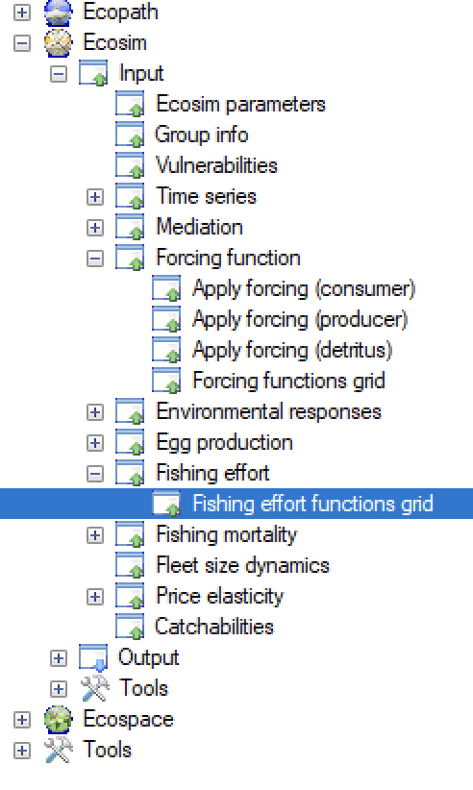
- Use the Fishing effort functions grid to copy in effort time series for each fleet that is normalised versus the base year in Ecopath. So effort for that year is 1 and the effort in every other year is relative to that base year (easiest to calculate as :
$${ecosim_effort_year}_{t}=\frac{{recorded_effort_year}_{t}}{{recorded_effort_year}_{base}}$$

As input is actually needed per month simply use the same scalar value (ecosim_effort_year_{t}) for each month. If you have historical seasonal management you wish to replicate this can be done by varying the value per month, but such detail is not needed per se and is left to user choice.

If copy pasting the values from another file (e.g. Excel file) please remember that you can only copy in a column at a time [There is an EwE idioscyncracy on this page which means you can copy out of the model the entire grid, but can only paste in one column at a time. Also it sometimes “forgets” the scalar values for the final month of the final year of the simulation so it is best practice to run it for 1 more year than you typically need, by repeating the final year of effort values, and then filter out that un-needed year in R when doing the subsequent calculations].

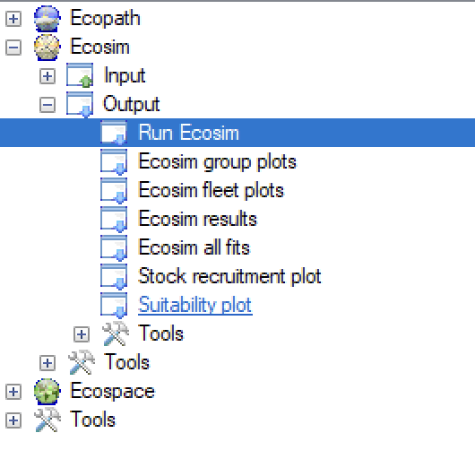
- Run the model (click Run on the lower right side of the run plot page)

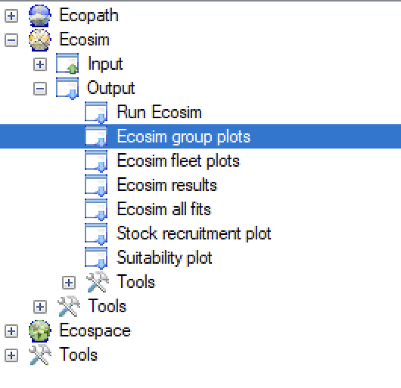
- Save the scenario using the Save results to csv button on the Ecosim group plots page (button on the lower right side of the plots page). This allows you to save the csv output to a directory of your choosing (a dialog box opens up and you navigate to where you want it; you can create a new folder if desired). This saves everything (more than you actually need).

Generating the unfished state

Obtaining the information for the unfished state can be done in two ways.
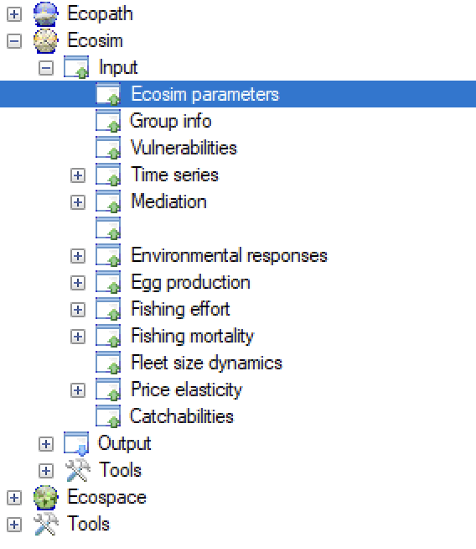
The first option all of the steps above for the historical fishing scenario can be repeated but with all effort in every year in Step 3 above set to zero.

If the resulting biomasses are not flat (i.e. reached equilibrium) by the end of the Ecosim simulation you may need to extend the simulation using the parameter Duration of simulation

on the Ecosim parameters page

The second option is to build an unfished period into the start of the historical fishing scenario. The idea is to run the model with no fishing to its unfished equilibrium and then apply the historical fishing effort time series. To do this go to the Model parameters
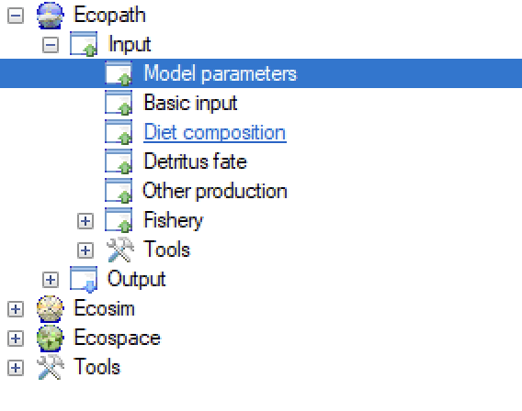
- Go back to Ecopath and artificially moving the parameter Model year (listed under Ecopath’s Model parameters) back in time by 50 or 100 years (50 is usually sufficient, though some models need 100 or even more time to reach unfished equilibrium)

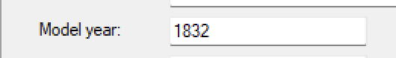

- The effort time series must now be modified. For example, if you have moved the model back 50 years in the step above then insert 50 years of zeroes at the start of the effort time series for each fleet. Remembering a value is needed for every month of those additional years. It is up to the user how they generate this new effort time series – whether via r or by coping into Excel, making the modifications and copying it back.

- The run the simulation and save the outputs as before

Calculating the Indicators

The file EBFM_indicator_calculation.qmd contains all the code necessary to calculate the various indicators. More on this below. First you need to create two helper files.

- Create an species_IDs.csv file (from the model input or output files above) but with the first column being the species/group names (identical to what is used as row and column headers from the matrices in step 1 and 2) and the second column being the ID numbers for the groups. Column titles are

ID | Group | PelDemID | PISCZOOPL | Linf_cm | MaxAge_yr | IsDetritus | Classification

ID: The EwE ID number (row number for that group in Ecopath front sheet)

Group: Name [typically as it is in EwE, but for the row and column names (the species/group names). You must make sure there aew no special symbols, like -, +, &, <, >, #, () or {} etc, or spaces in the name. I typically just replace them with an underscore _.

PelDemID: whether the group is (in gross terms)

Term | Description
TEP | Threatened, Endangered, Protected (typically marine mammals, marine reptiles, seabirds, sharks)
Pelagic | Pelagic finfish
Demersal | Bathy or demersal finfish
Jelly | Jelly fish
Invert | Other invertebrates (pelagic of demersal)
Micro | Microfauna – zooplankton, bacteria
Phytoplankton | Phytoplankton
Detritus | Detritus

PISCZOOPL: whether the group is (in gross terms)

Term | Description
TEP | Threatened, Endangered, Protected (typically marine mammals, marine reptiles, seabirds, sharks)
Piscivorous | Finfish with piscivorous diet
Planktivorous | Finfish with planktivorous diet
Jelly | Jelly fish
Invert | Other invertebrates (pelagic of demersal)
Micro | Microfauna – zooplankton, bacteria
Phytoplankton | Phytoplankton
Detritus | Detritus

Linf_cm: Max length for the species group (even if juvenile life stage just put the maximum adult size). This does not have to be precise it is simply to gain a rough guide of size structure if it is necessary to fall back to some of the supporting diagnostics.

MaxAge_yr: Max age for the species group (even if juvenile life stage just put the maximum adult age). This does not have to be precise it is simply to gain a rough guide of system scale max age structure if it is necessary to fall back to some of the supporting diagnostics.

IsDetritus: 1 if detritus otherwise 0

Classification and Class_Code: This is used by green band plots (to determine what goes on what plot) and the ETI (as it calculates relative state per class). The classification/class codes are:

Classification | Description
Vulnerable | TEPs and species with “K selected” life histories
Habitat | Biogenic habitats like seagrass, mangroves, kelps, corals, oyster and sponge reefs etc
Byproduct | Species that are worth enough to land but not the primary targets of the fisheries
Bycatch | True incidental capture and discarded
Target | Target species of the fisheries
Robust | Very fast life histories (all plankton, cephalopods, forage fish if not target or byproduct)
The Hub species will be added to these classifications when the code is run.

Also create a Fleet_ID.csv file with the following format:

ID | Fleet name

ID: The EwE ID number for the fleet (row number of the Fleets page)
Fleet name: Typically the name as on the fleet page in Ecopath (or something meaningful to you), you must make sure there are no special symbols, like -, +, &, <, >, #, () or {} etc, or spaces in the name. I typically just replace them with an underscore _.

Set up EBFM_indicator_calculation.qmd for your system

Open the quarto file in Rstudio then starting at the top of the file and fill in the input information required in the first 4 code chunks (the blocks with the little green arrow in the top right corner). These code chunks in this section set up the working directories, files and parameters for the rest of the code to use.

You do not need to run the code yet, just fill in the required information.

The first chunk cleans up the workspace memory (removing anything currently in the global environment memory from previous work being done in R). Then it asks for information to configure the workspace for calculating the indicators.

Before running this chunk please fill in the following pieces of information for your case

mainDir <- “directory_where_qmd_and_species_ID_and_fleet_ID_files_kept " # like setting the working directory
InsubDir <- "modelOutput _directory " # Path to EwE master output directory
InputsubDir <- “directory_in_EwE_output_directory_with_historical_scenario_output”
BosubDir <- “Directory_holding_no_fishing_run_output”
OutsubDirStep1 <- "top_directory_for_output "
OutsubDirStep1 <- “sub_directory_where_you_want_r_script_plots_stored_as_saved”

Note that the path BosubDir is only actually used if used the first option (a separate scenario) for the no fishing option is used. If you used the second option (where additional burn in years at the start of the simulation are used), you must put something there regardless (even just “”), but it will not be used.

Also if you do not want the two step structure for the output directories (i.e. just want an output directory were everything goes) then set one of these entries to ""

The second chunk is the name of the input files needed. Please enter the name of the files you have created for your model:
- The species file created by the user as described above
species_ID_filename <- "Species_ID.csv"
- The file created by the user as described above
fleet_ID_filename <- " Fleet_ID.csv"
- The consumption file as output by EwE
consumption_filename <- "consumption_from EwE.csv"
- The diet file as output by EwE
diet_filename <- "diet_from EwE.csv"

The fourth chunk are all the parameters describing your model and simulations.
The first three parameters are needed when calculating the hub species.

use_weights indicates whether you want to use weighted links or 1-0 (presence-absence) links. Typically set to 1
use_weights <- 1

A flag indicating whether detailed network information needs to be saved. These are additional network indices like centrality, closeness, betweenness, SURF and criticality indices. These are in additional to those used to calculate the hub species (which will be saved automarically). Typically set to 0
detailed_check <- 0

A flag asking whether to strictly use the top 5% of hub scores as hub species or relax this to 10%. For moderately small models of 20-30 groups 5% might give very few returns (1 or 2) and if these are all plankton that is not helpful so using 10% can be better then
use_top_5_pct_only <- 1

The rest of the parameters are to do with calculating the rest of the system indicators

If you used the first option above to generate the unfished biomasses (separate unfished scenario) set
bo_in_same_file <- 0

If you used option 2 (unfished period at the start of the historical effort scenario) set
bo_in_same_file <- 1

Now define which year of the simulation to use as your unfished biomass reference year. In the example below I have written n, where n is the row of the time series that is the year before historical effort begins
bo_yr_row <- n

For example, If you used option one to generate the unfished biomass (separate run) and the simulation lasted 50 years you could pick any year after the biomasses stabilised (flat lined) in that simulation. Typically, you pick the last year, so
bo_yr_row <- 50

If you used option two to generate the unfished biomasses (i.e. extra burn in years at the start of the simulation) and the simulation began in 1850, with the first year of non-zero effort in 1950 then
bo_yr_row <- 99

As R starts its column count at 1, setting bo_yr_row to 0 would cause an error. In that case the code defaults to using the last year.

If you want to filter out the early years of the EwE output from the plots an analyses (this is particularly the case if you used the second option above for your unfished biomasses and you are not interested having a long meaningless burn-in at the start of each plot) then set yr_ignore to the calendar year of the first year of the historical effort (so 1950 in our example immediately above). It will not plot any earlier year.
yr_ignore <- m # where m is the calendar year

Note if you did not give a base year in Ecopath but left that parameter blank, Ecosim will not use calendar years but simply number the years 1 to how ever many years you have in your Ecosim simulation. In that case set yr_ignore to the first year you want to plot (so if you had 100 years number 1 to 100 and you only wanted to plot from year 55 onward then set yr_ignore to 55).

Set the geographic area (km2) of the model (as defined in Ecopath or your model documentatiom). This is used to convert the EwE t/km2 into tonnes for reporting purposes
area_model <- 10000040

Calculating the indicators.

One the information above has been entered you have a choice. You can simple click render button (blue arrow) at the top of the R studio screen to generate a html file of the output.

Or you can run each code chunk sequentially (starting at the very top of the file and working your way down one chunk at a time). This will not create the html, but all the individual plots should still be saved in the output directory.

If something goes wrong and you have to go chunk by chunk to see why you can always go back and Render it. To clear output and do it from scratch Click the little while beside the Render button and click “Clear All Output”. After you’ve done that you might find that when you Render the file again R does not automatically open the html file on Render completion, that is still ok. Simply go to the file in the directory (e.g. using explorer on Windows or Finder on Mac) and double the html file and it will open in your web browser.

Code Workflow Logic
For those trying to understand what the code is doing the logic flows as follows

Configuration and Set up
- Clean-up memory
- Define directories
- Give the names of the input files
- Configure the model parameters
- Point the supporting code (functions to be used in the calculations)
- Load libraries that will be needed (installing any missing ones)
- Check the final output directory is there and create if need be
- Data (EwE csv files) loaded
- Point to the supporting graphics configuration (parameters used in plotting)

Finding the Hub Species

- Loads in the raw consumption and diet matrices, and the species_ID.csv file and cleans them up ready to do the network analysis
- Creates the hub species and saves the results for use later
- Reports back what the hub species are

Generate some useful diagnostics

- Loads on the Ecosim output
- Plots time series of biomass and catch
- Plot of discards and discard rates timeseries (which can also be used as an index of pressure on the system)
- Run principal components analysis of the catch composition

Calculate indicators commonly used around the world for EAFM/EBFM

- Exploitation rates (index of pressure on the system)
- Total Landings/ Total exploitable biomass (index of pressure on the system)
- Piscivore:Planktivore and pelagic:Demersal biomass ratios (give some sense of gross ecosystem structure and how it changes through time)
- Coefficient of variation of ecosystem (t) versus individual (i) – an index of resilience and disturbance
- Mean length (weight or max length) in a community or catch, mean trophic level of community, catch, mean longevity and proporation of large fish (LFI) - all considered indices of ecosystem status
- Ryther ( catch per unit area), Fogarty (total catch / total primary production) and Friedland (catch: chlorophyll) – all indices of the amount of pressure put on the ecosystem at a system level
- Cumulative biomass (survey or catch) vs Trophic level – steepness of the curve and height of the asymptote are indicators of overall system state

Indicators focusing on system structure
- Green band
- Gao
- ETI
- Heatmap (helps see how things have contributed to the catch over time, its another useful diagnostic and by annotating it with key events like new gears, new laws, extreme events it can help with the interpretation of the ETI and other indices)

Example files
A short example is provided along with the code. It is not particularly exciting (there is not a lot of contrast in the short time series), but it is to show you the lay out of the directory structure and how the set up looks in a working example.

To get this example to work on your machine, replace
“/Users/ful083/Work/Lenfest_EBFM/case_studies/SE_Aust/EwE_model_output” with the name of the directory where you have your files.

Note on windows you might need to use \ not /.

Developer Contact

This quarto code was created on a Mac. It is untested on Windows. There may be problems I have not encountered or thought of (sorry!).

In the case of any problems please contact beth.fulton@csiro.au. I get a lot of email so if I haven’t answered in 3 days and you still need me email again (sorry to be a pain), and perhaps mark at as High Priority to get my attention.

